114-23-10700-2005 ROUTE CORRECTION
Water body name: Survey date: 6/29/2024
Quad: Juneau A-6 Species & Lifestage: CHp, COp, Pp, Sp, DVp
Upper Reach Latitude: 58.146977 Longitude: -135.893515 Survey crew: CD, DK
Lower Reach Latitude: 58.149700 Longitude: -135.911868
Findings: We surveyed this cataloged stream using a GPS and found that the stream path is incorrectly mapped. No data points or photos were taken during this survey but based on GPS tracking while walking the stream and satellite images, it was determined that the current stream path is incorrect.
Recommendations: Correct Stream No. 114-23-10700-2005 in the anadromous waters catalog to reflect the field verified stream path (Figure 1).
Nomination: Pending

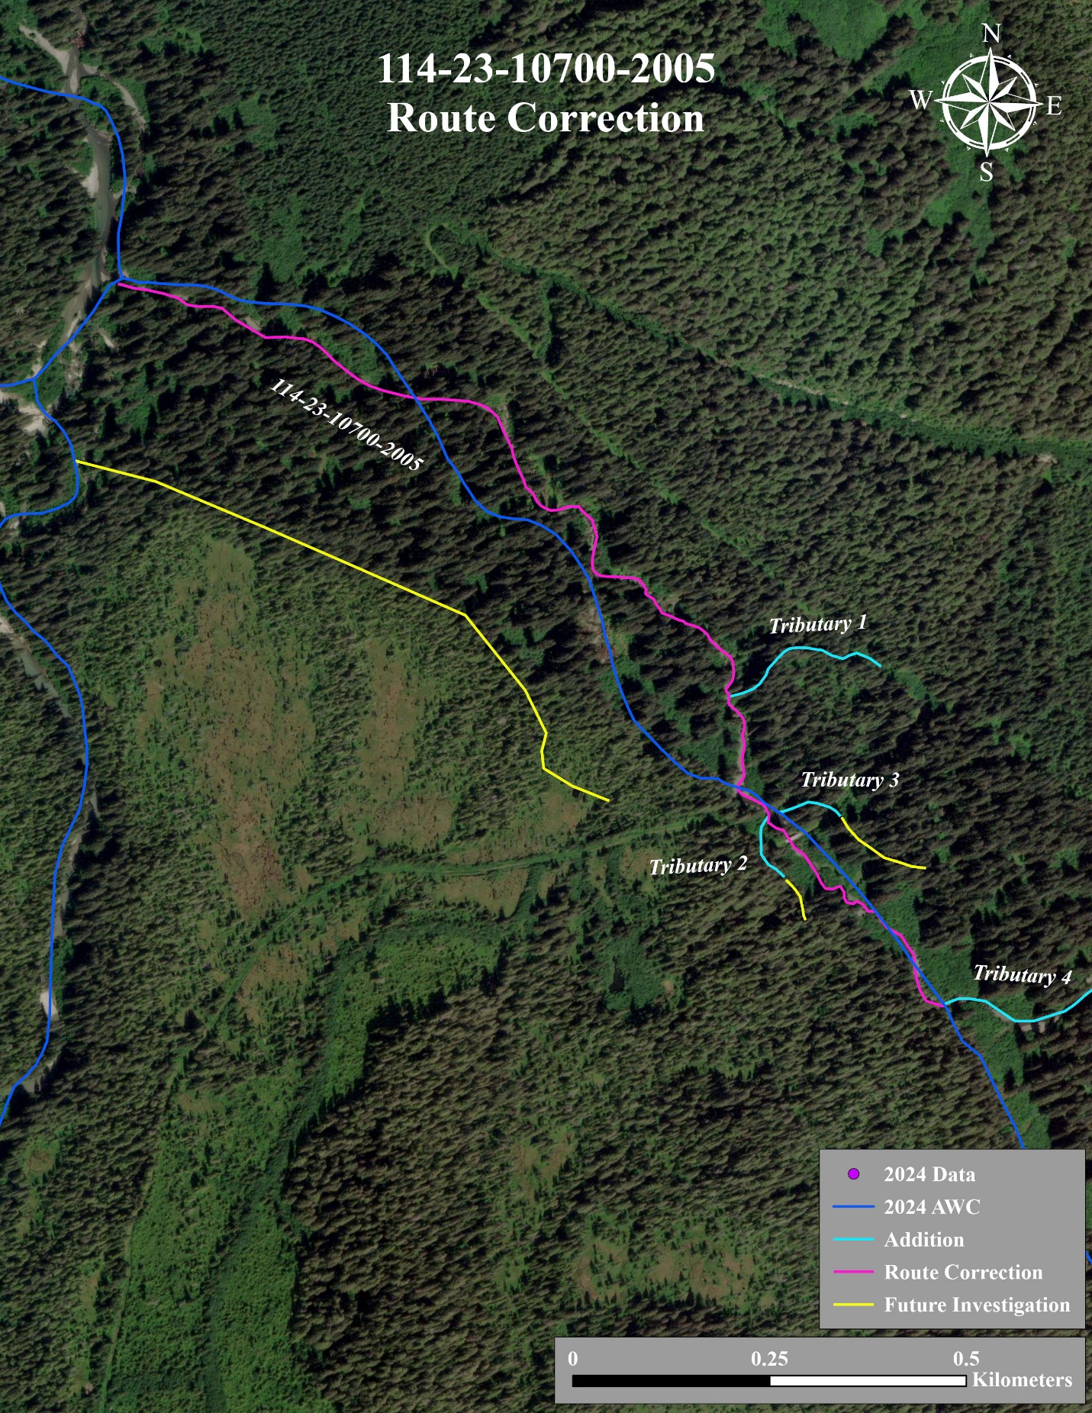
Figure 1.–Stream No. 114-23-10700-2005 Route Correction.

